EBS VOLUMES AND SNAP SHOTS PRACTISE

Here, we have created an instance

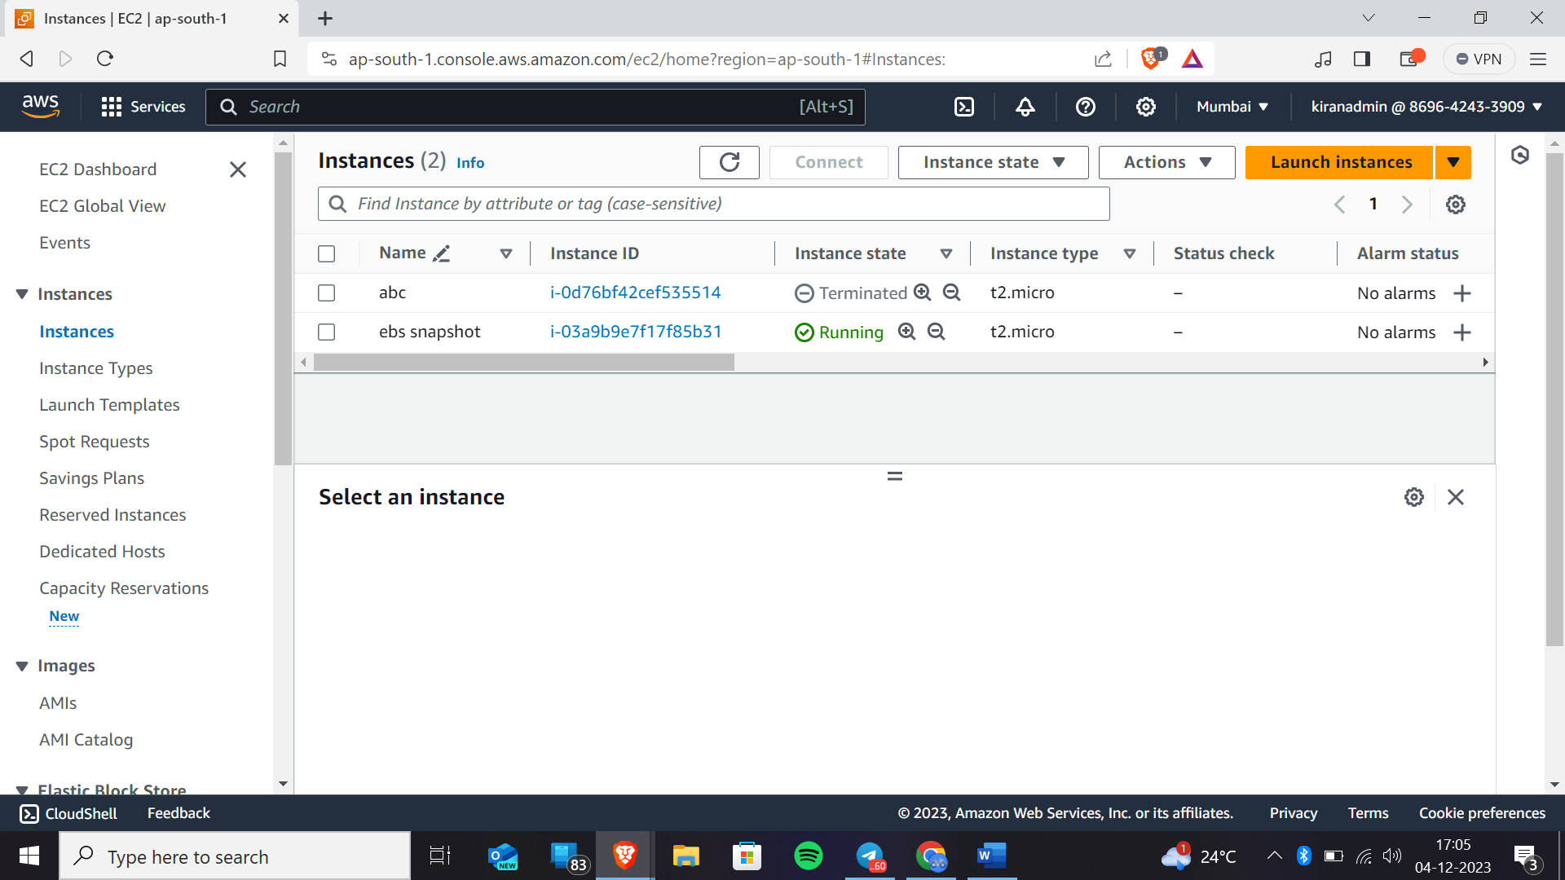

Now click on elastic block store->volume

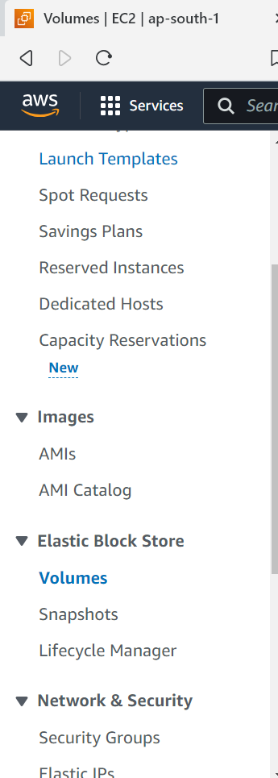

We will get the page like this

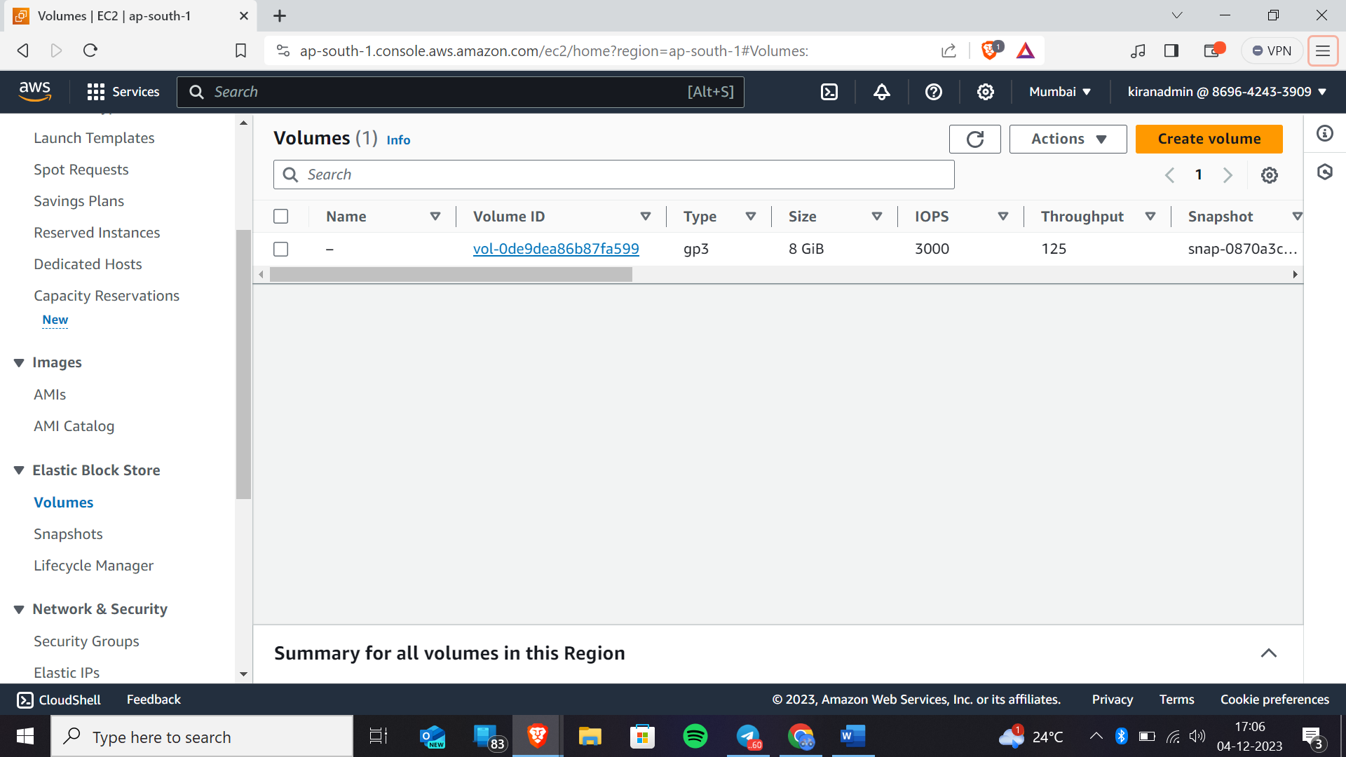

What is snapshot?

A)A snapshot is the backup of the volume that you can take backup of that volume to any availability zone or any region

Now create snap shot by selecting the volume

Creating snapshot

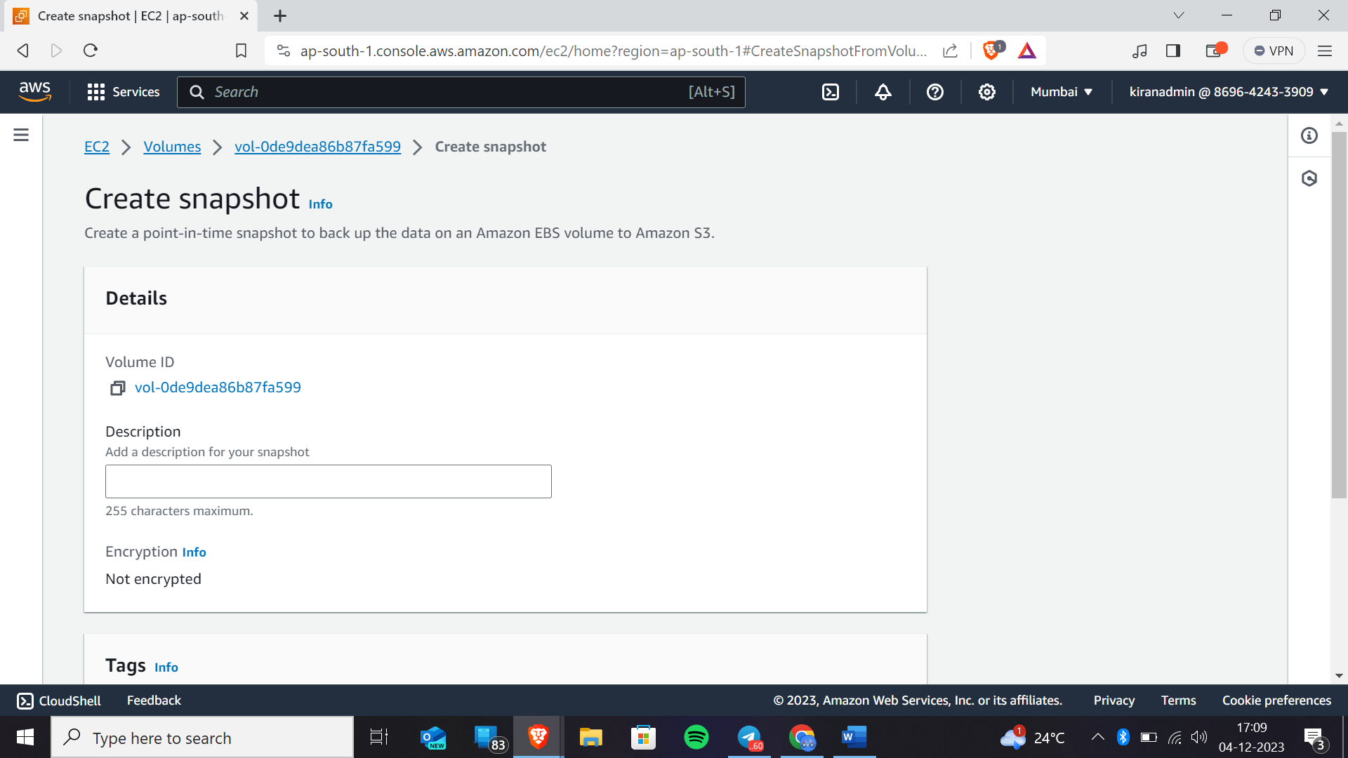

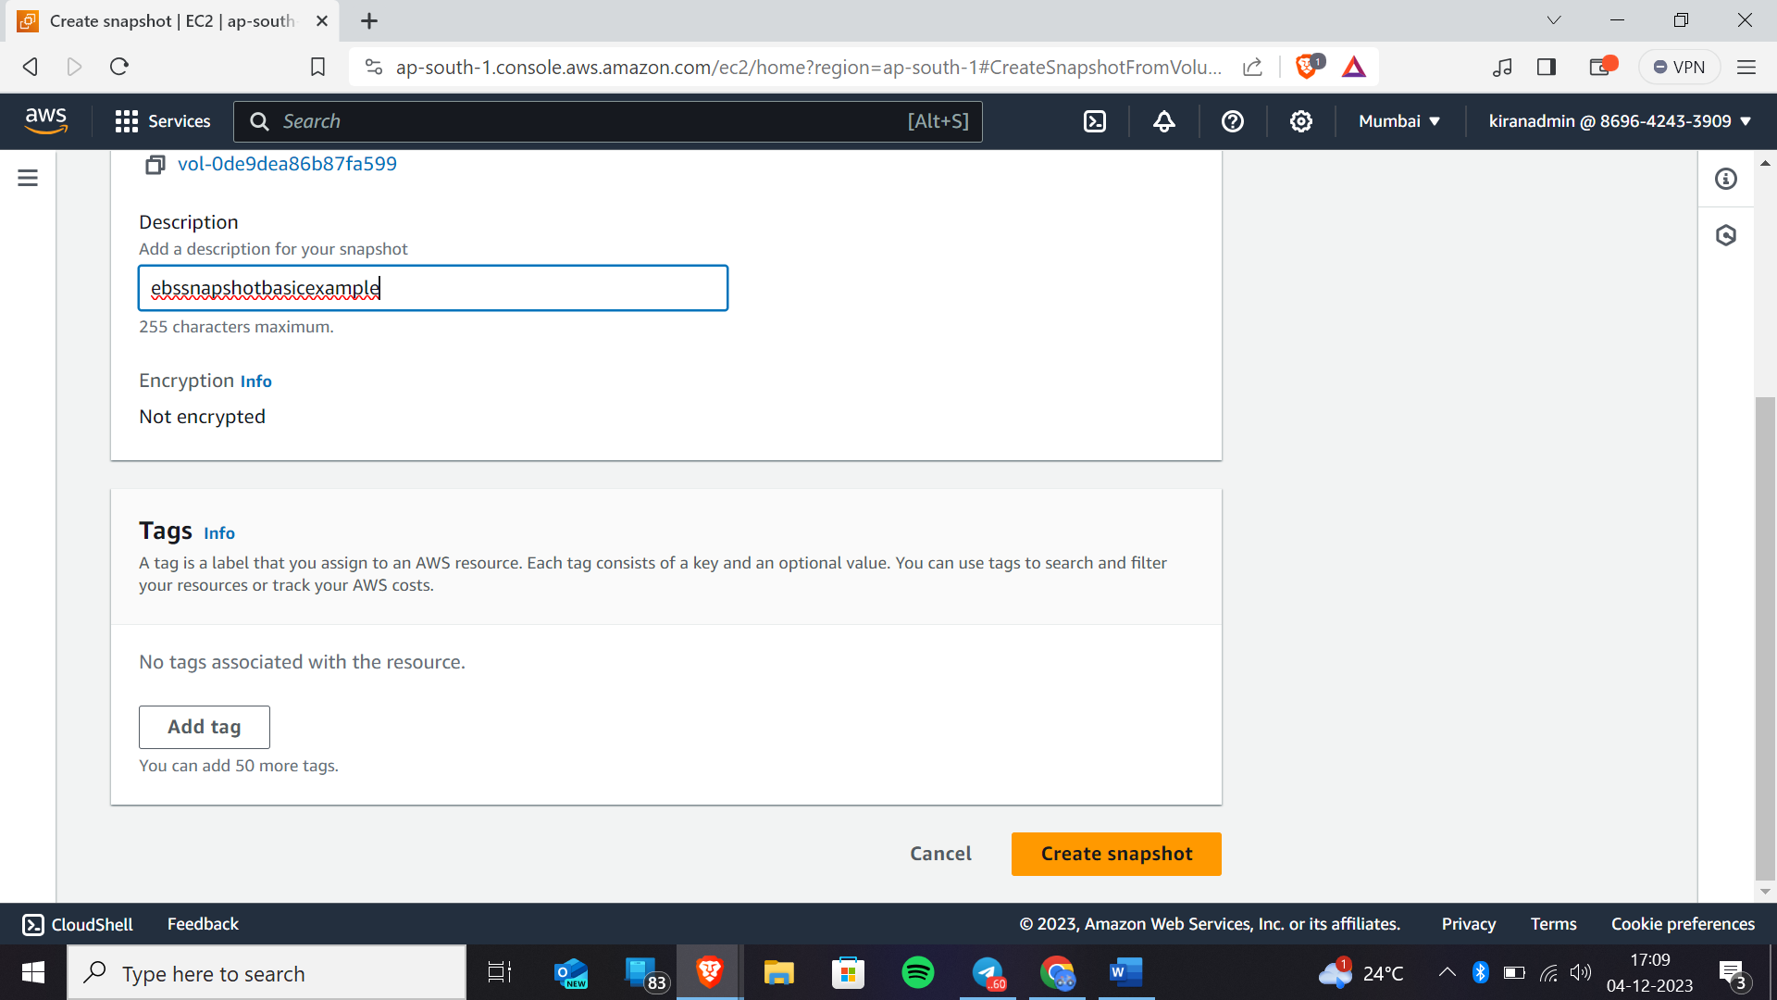

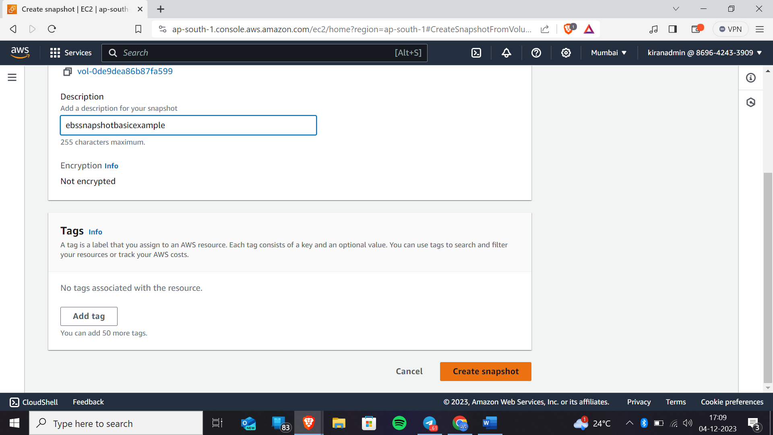

As we have created snapshot now click on snapshot module available in left side under elastic block store

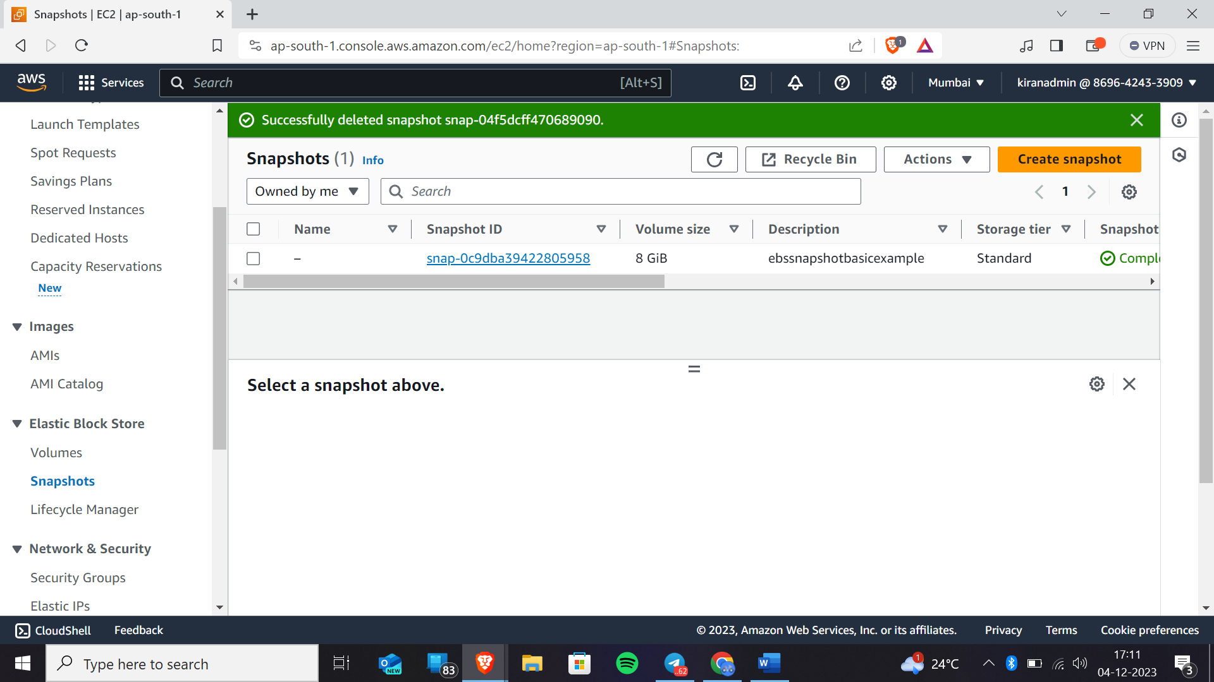

This is the snapshot that we have got

As we know that if we delete the snapshot by accidentally then it will be retained in recycle bin before that we have to create retention rule.

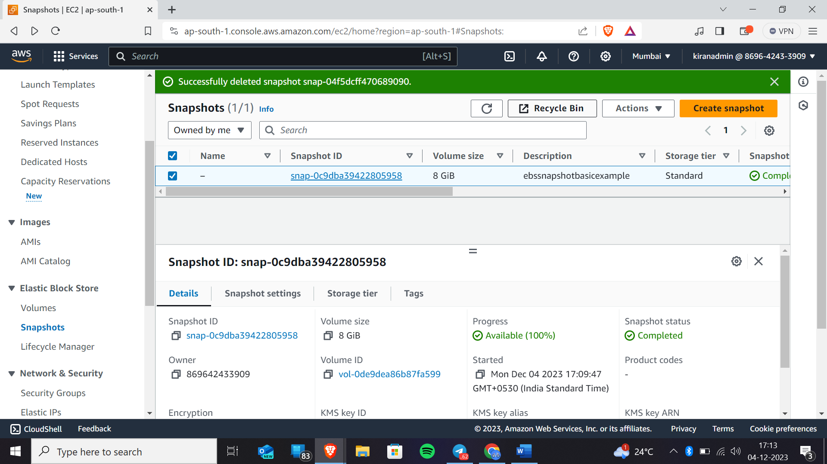

Now click on create retention rule

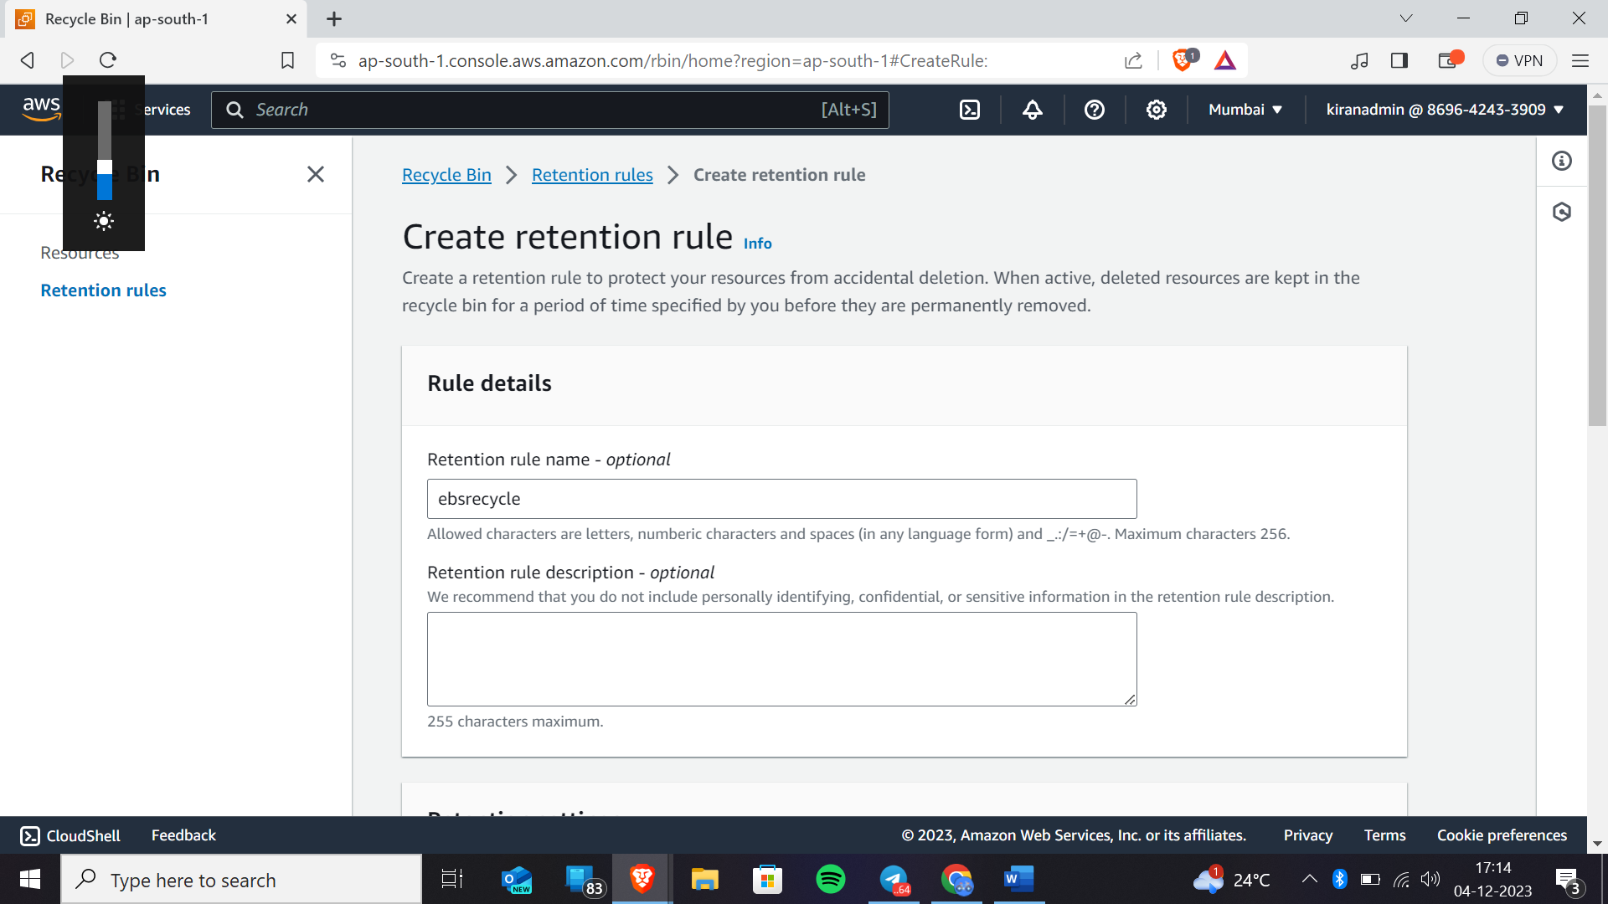

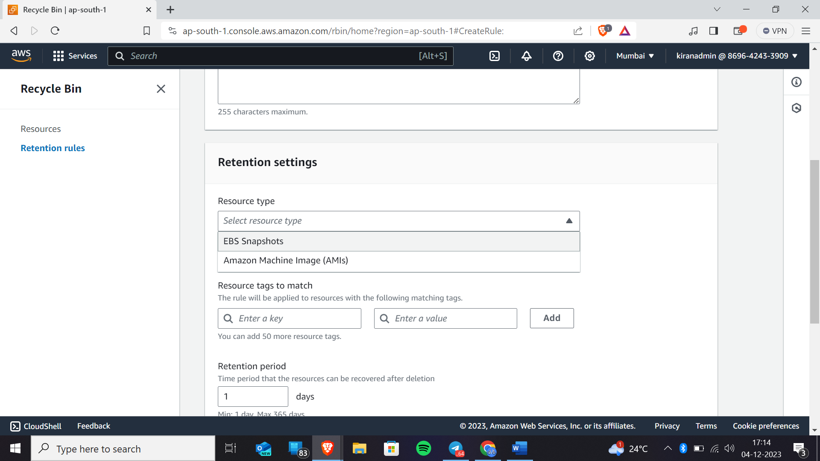

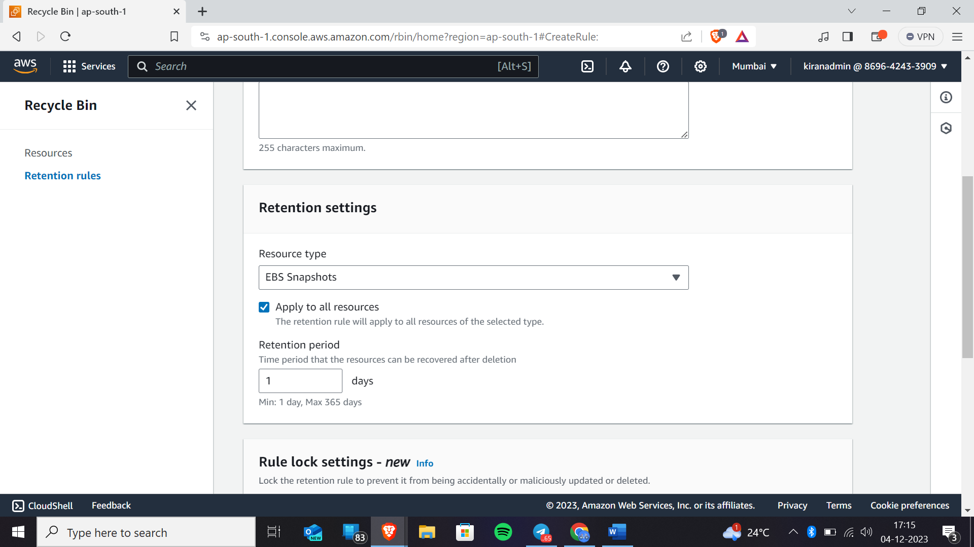

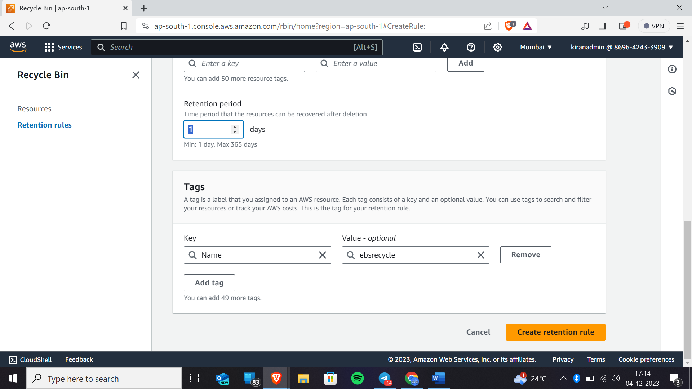You can select the retention period of your snapshots minimum is 1 day to and maximum is 1year.

Here I’m creating for the 1 day

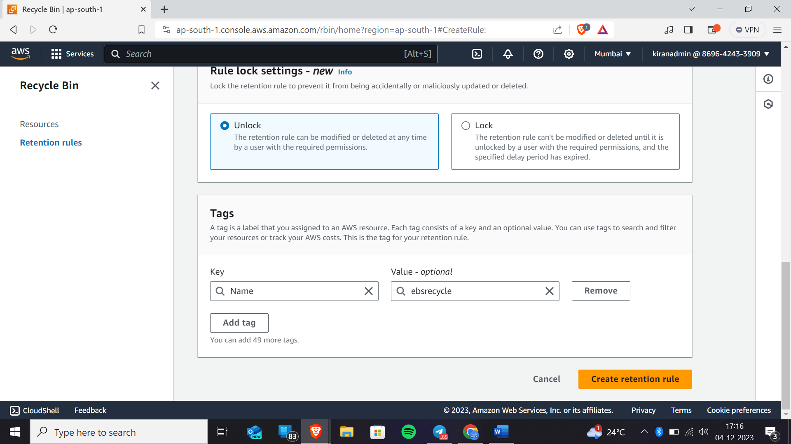

Now click on create retention rule.

Now go back to the “snapshot module” and let us delete snapshot and recover that snapshot.

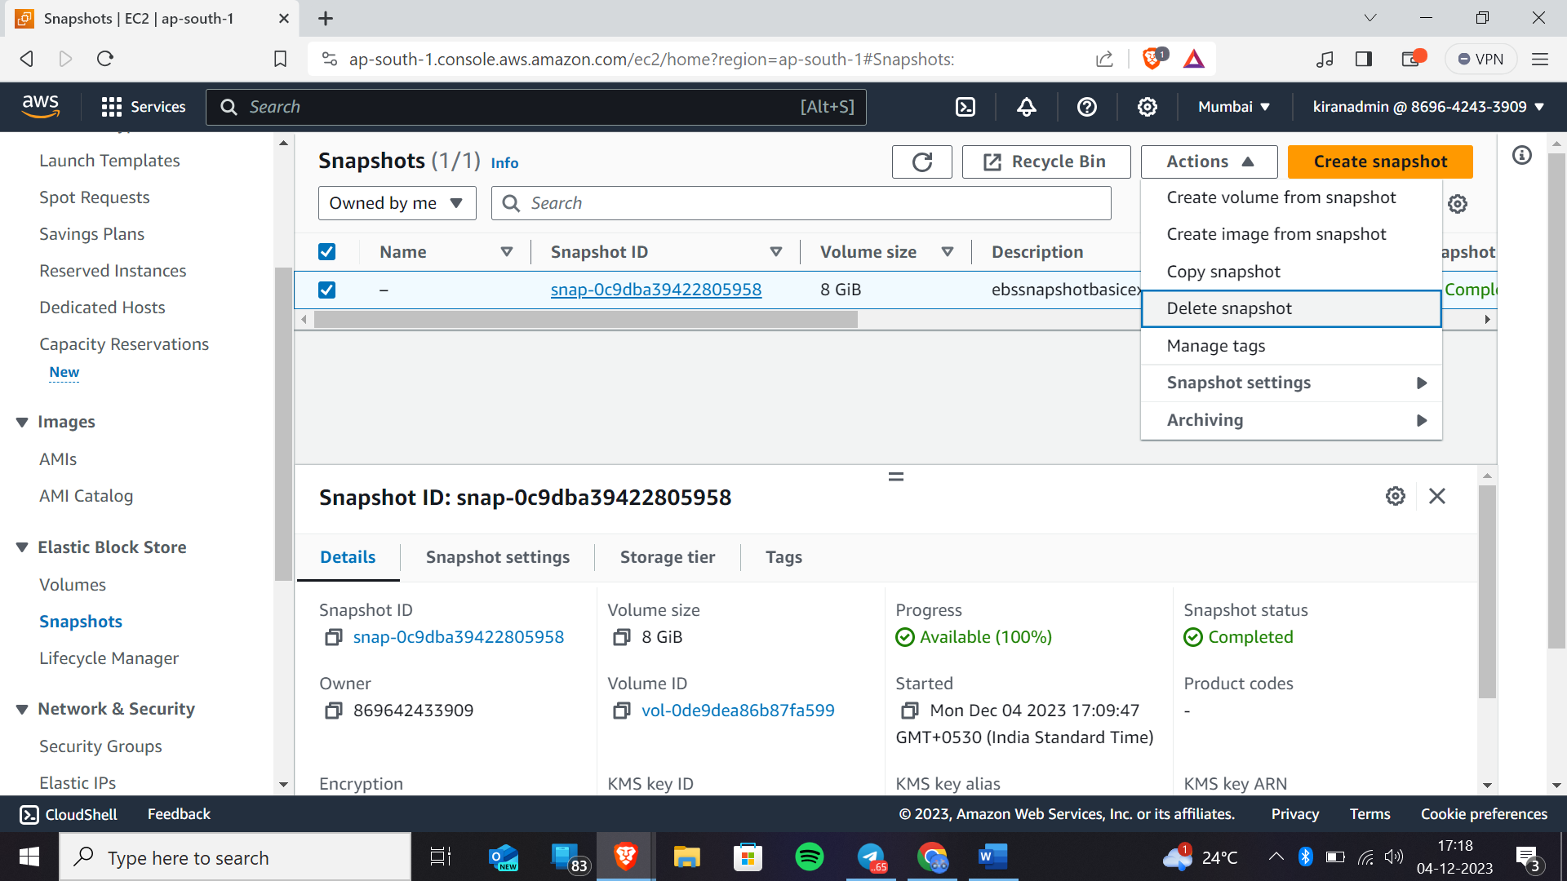Here we are deleting snapshot

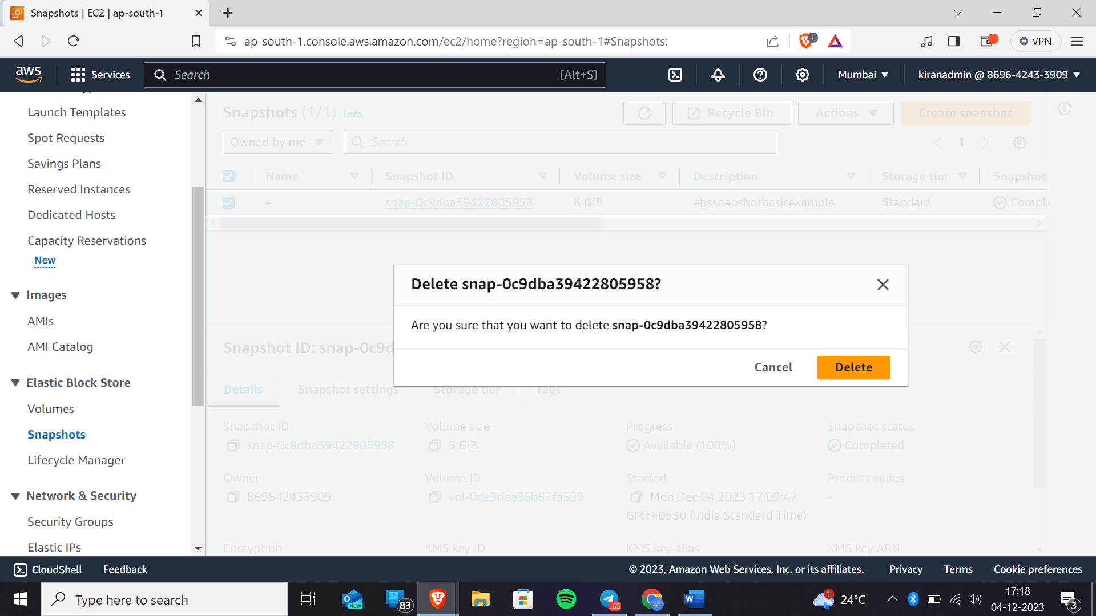

Now click on recycle bin

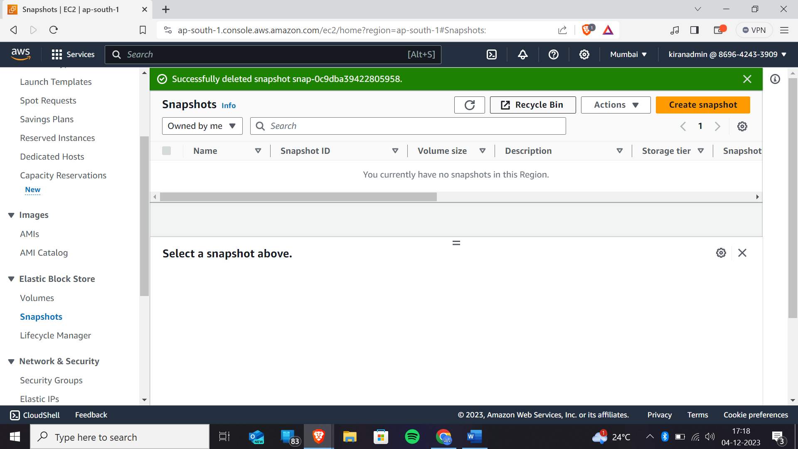Now click on resources

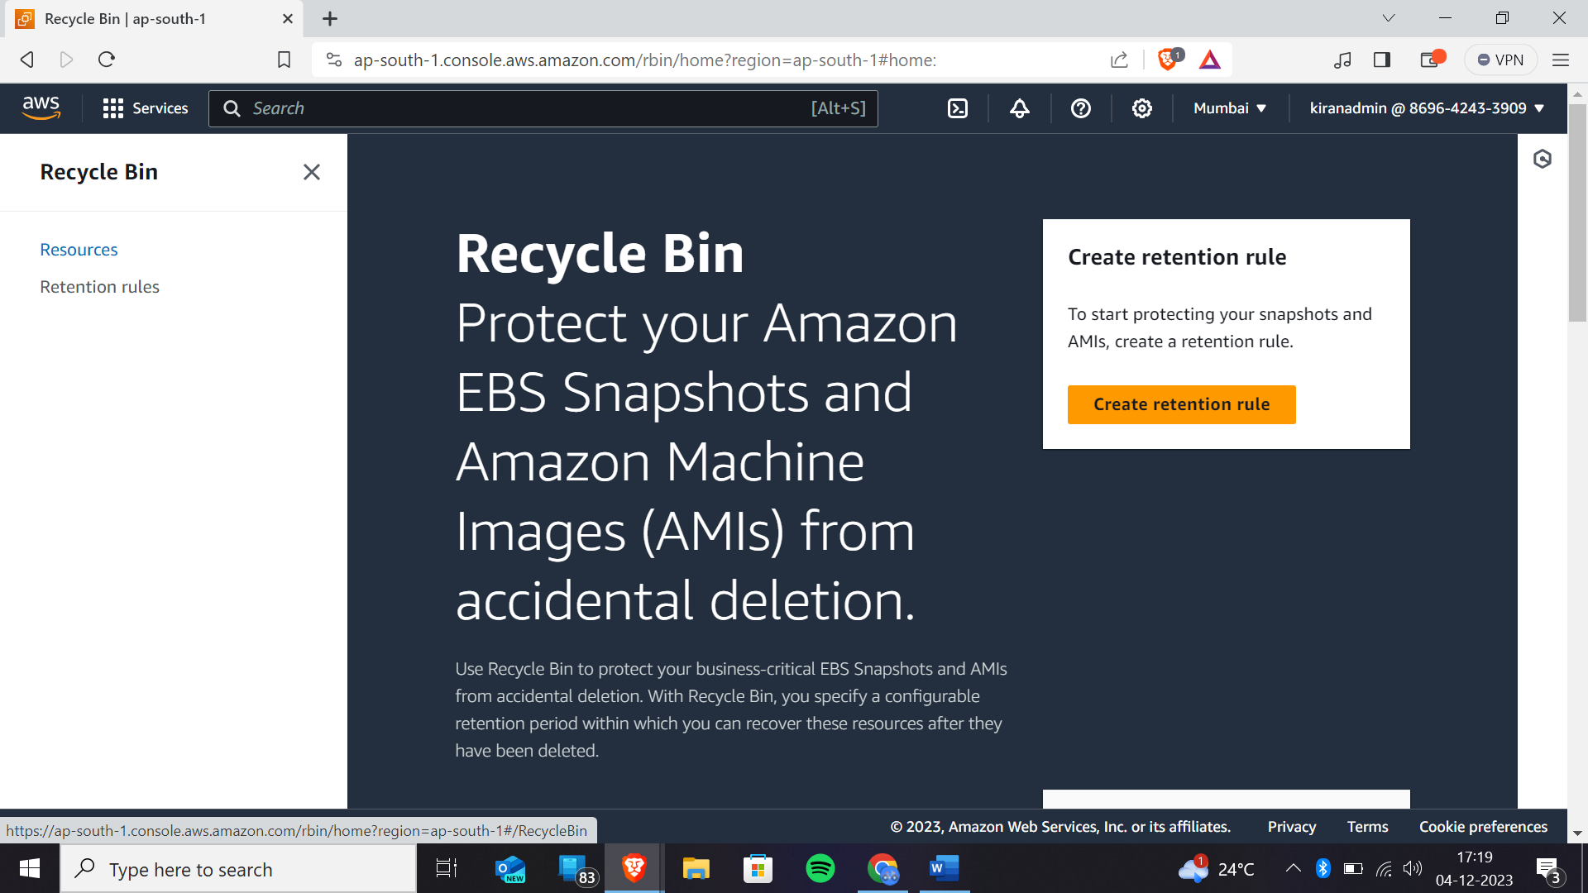

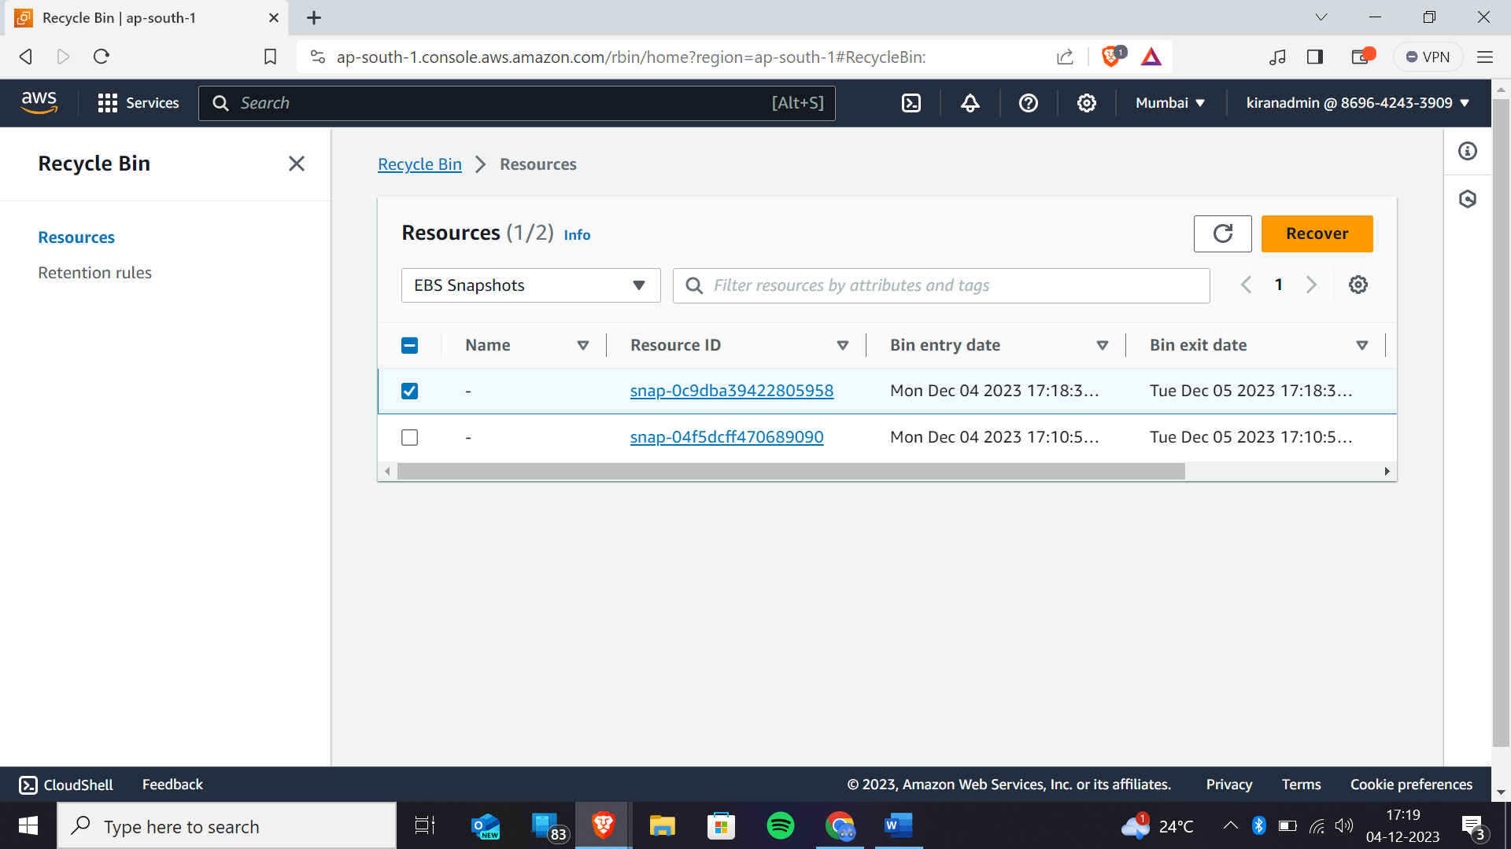As we have deleted the snapshot you will get the snapshot instantly into the resources and select that required resource that you wanted to recover and click on recover

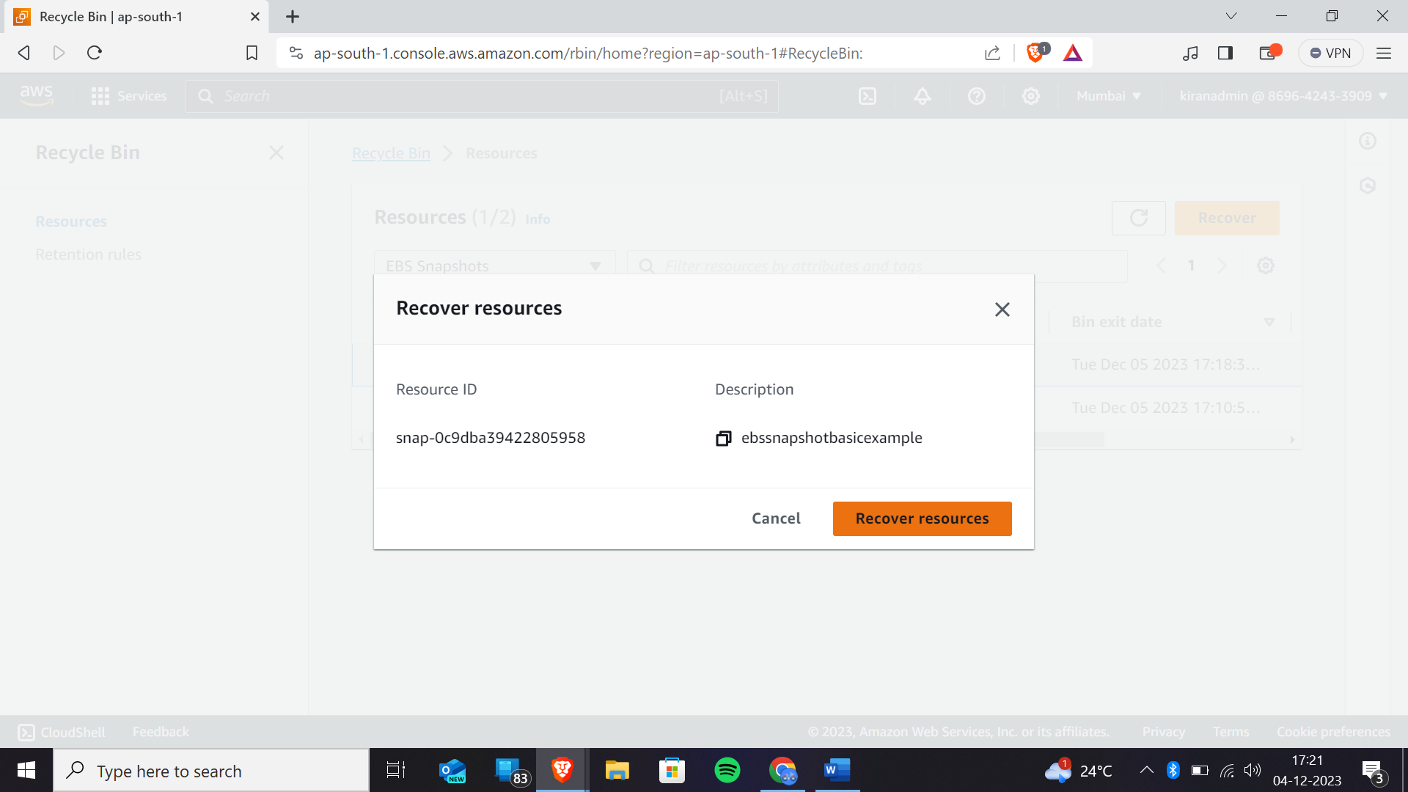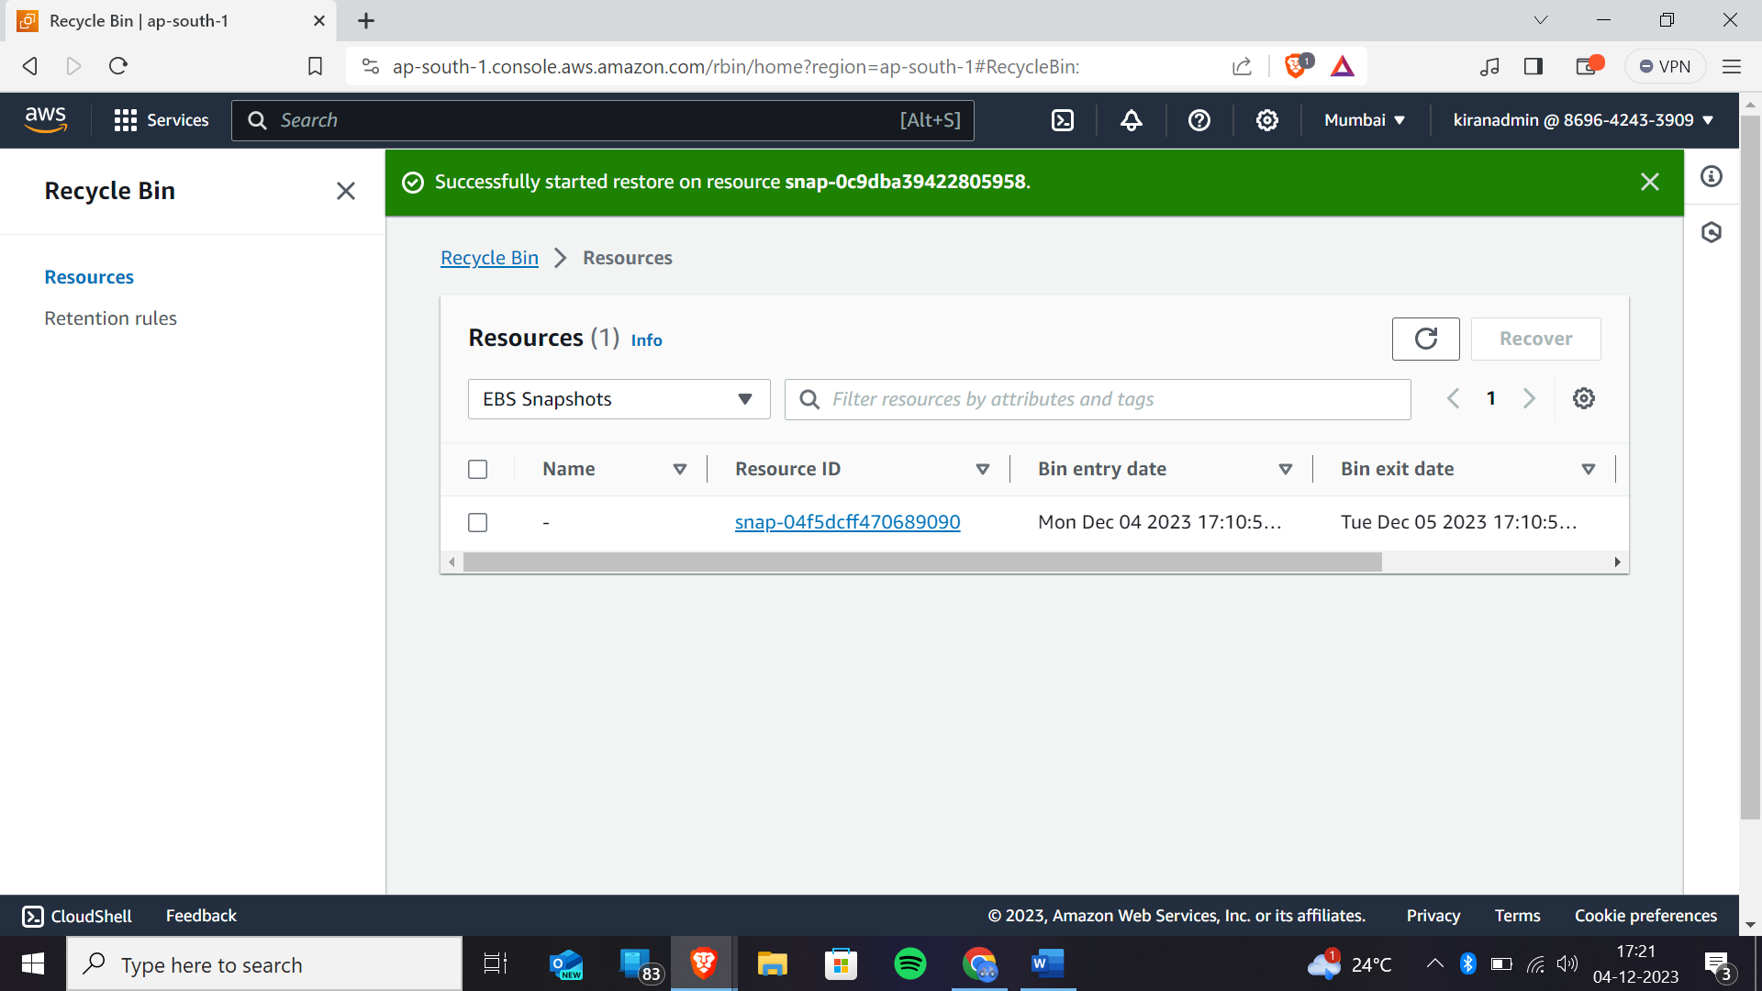

When coming back to the snapshot module you will get the snapshot recovered

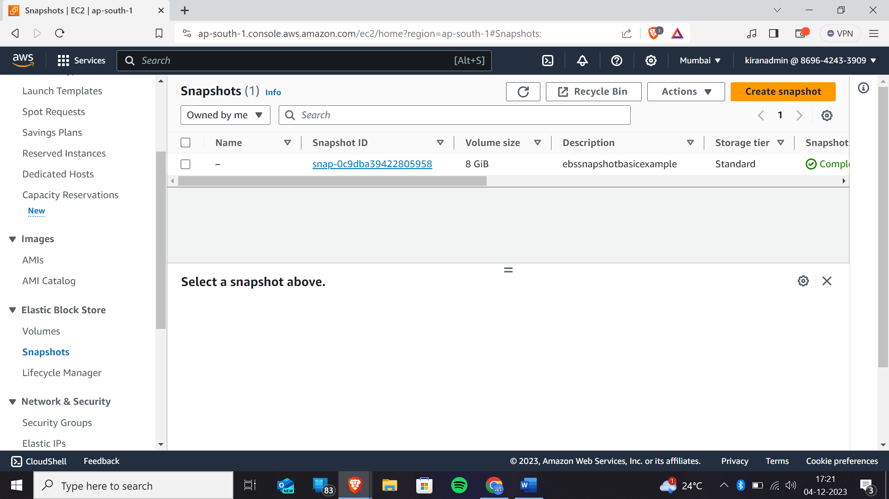

Now if you want your volumes to be moved to the another availability zone or to the another region then now follow the following steps

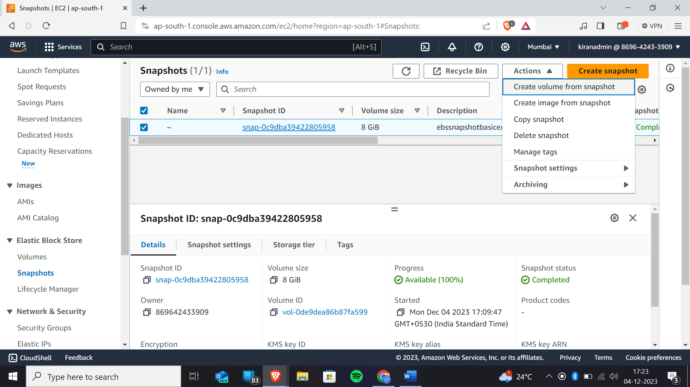

After clicking on create volume for the snapshot we will get like this.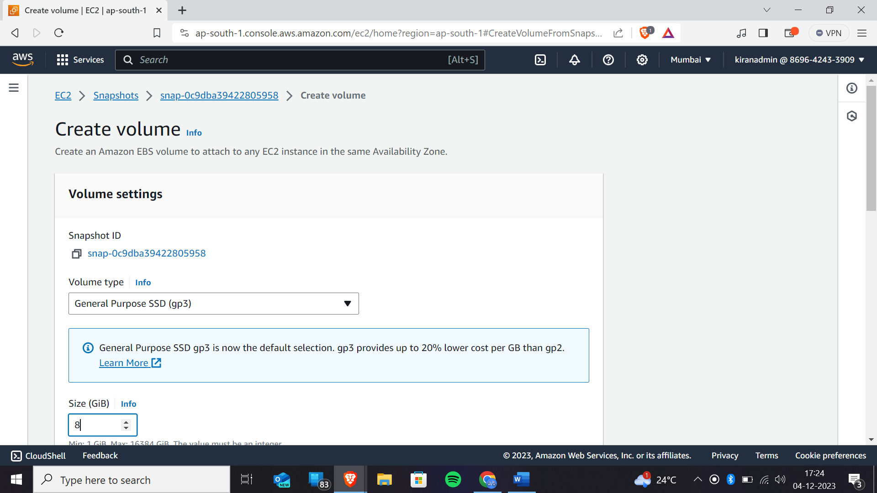

For which availability zone you are wanted to migrate you can select here

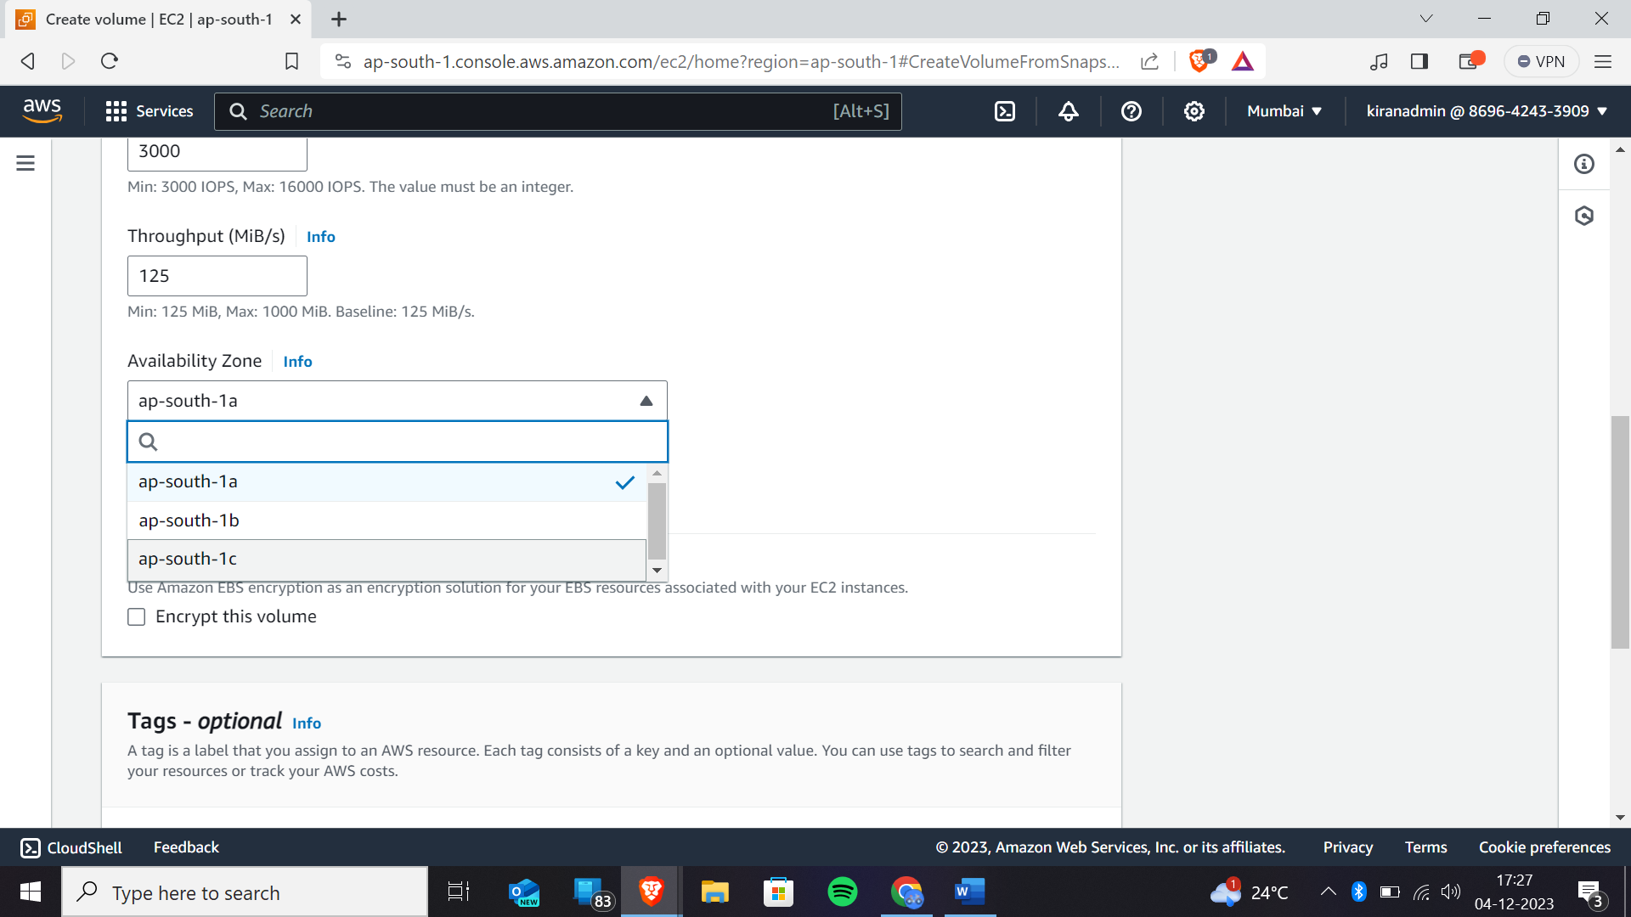

Now click on create volume

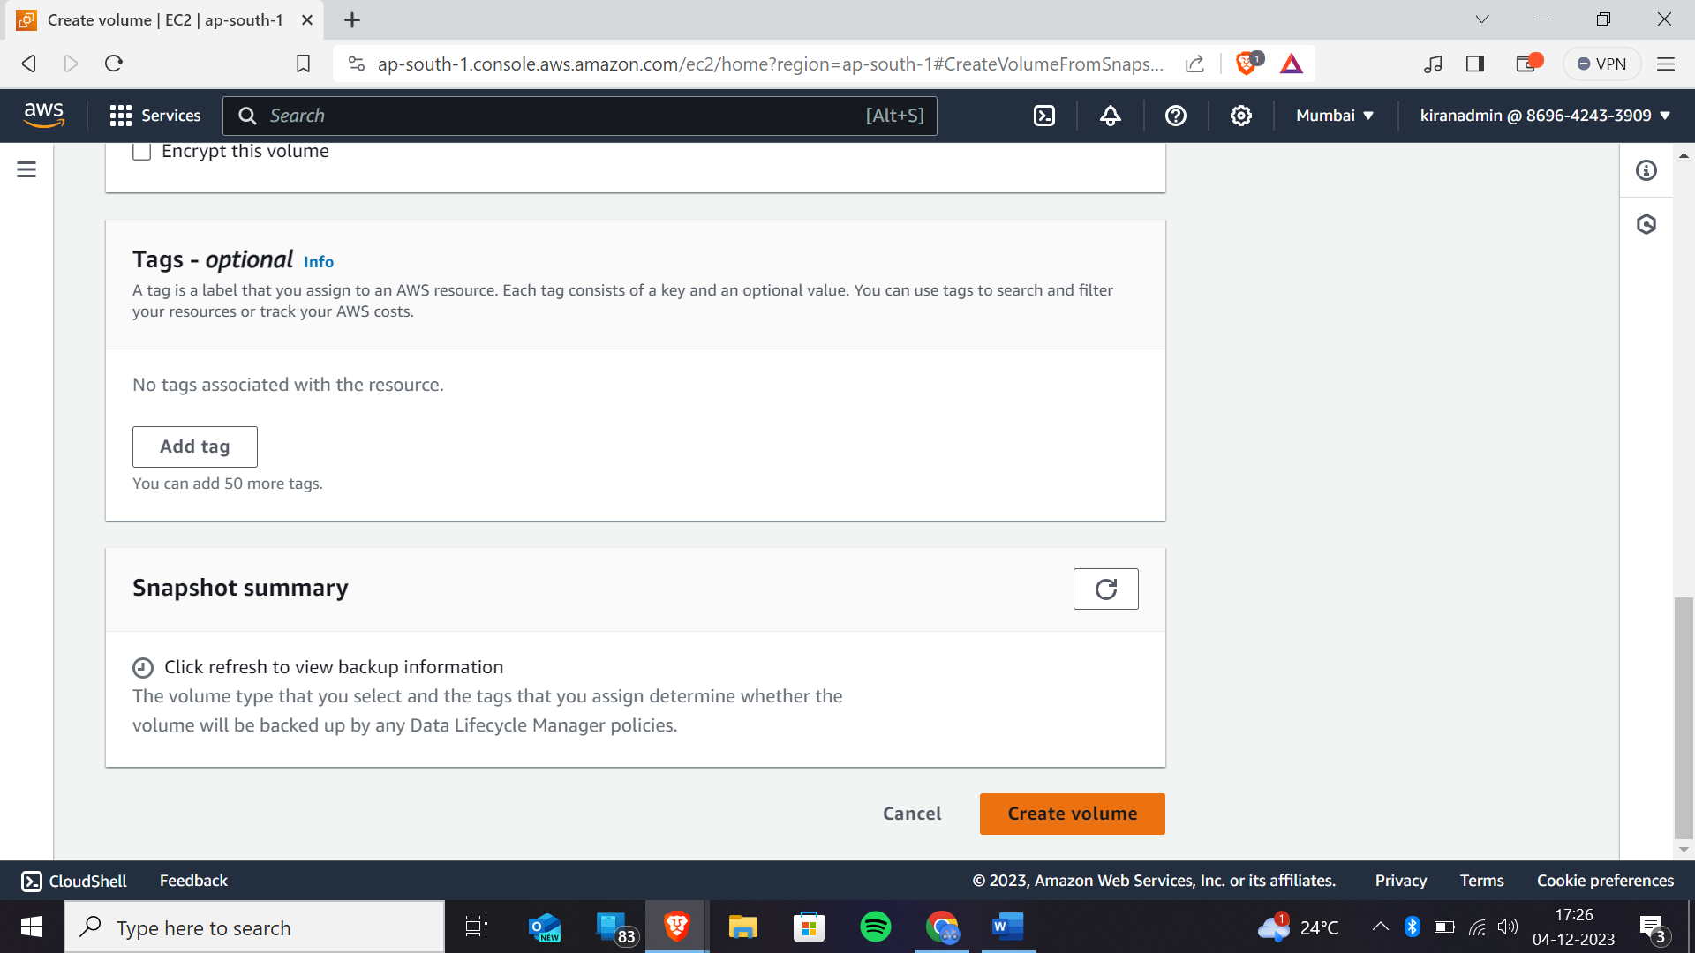we have successfully created volume

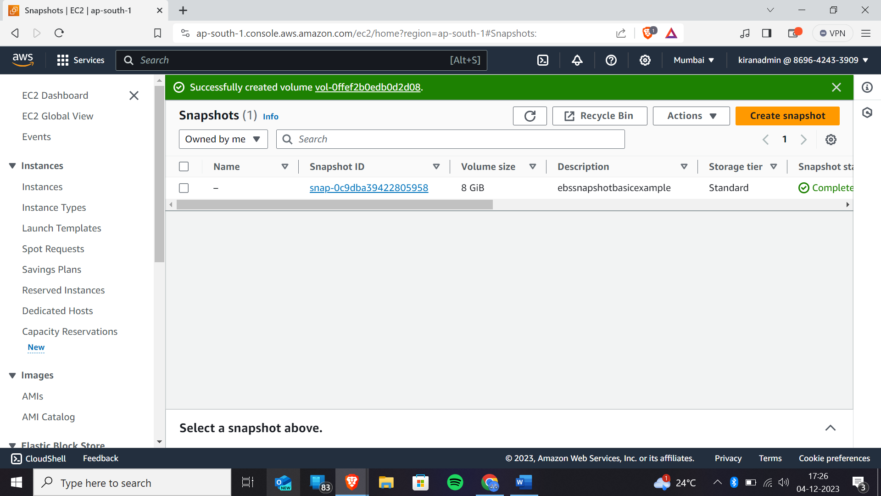

Now you can see that the volume is created in another availability region

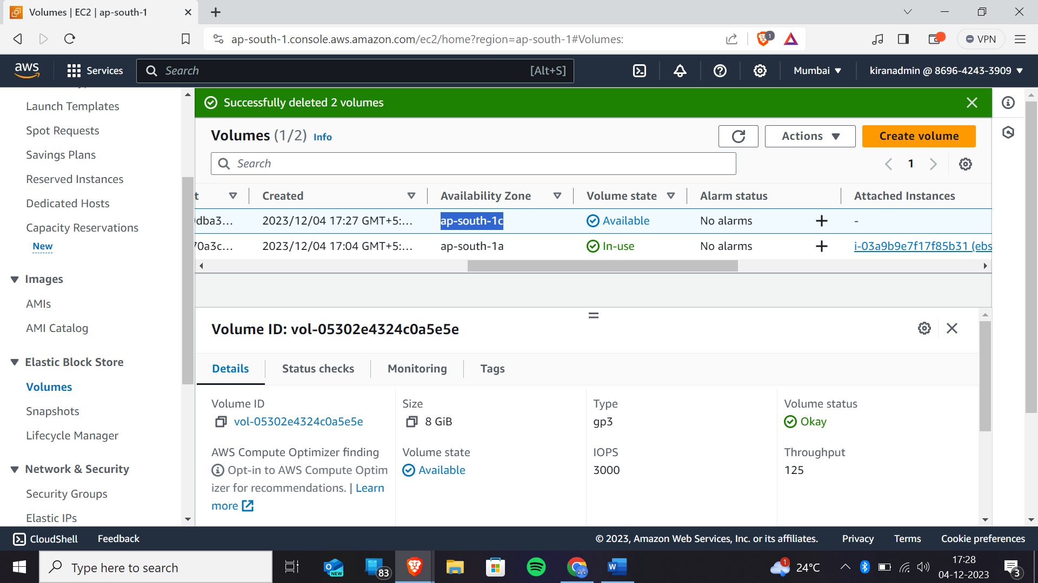

“””””””””COPYING SNAPSHOTS TO DIFFERENT AVAILABILITY ZONES/REGIONS”””””””””””””

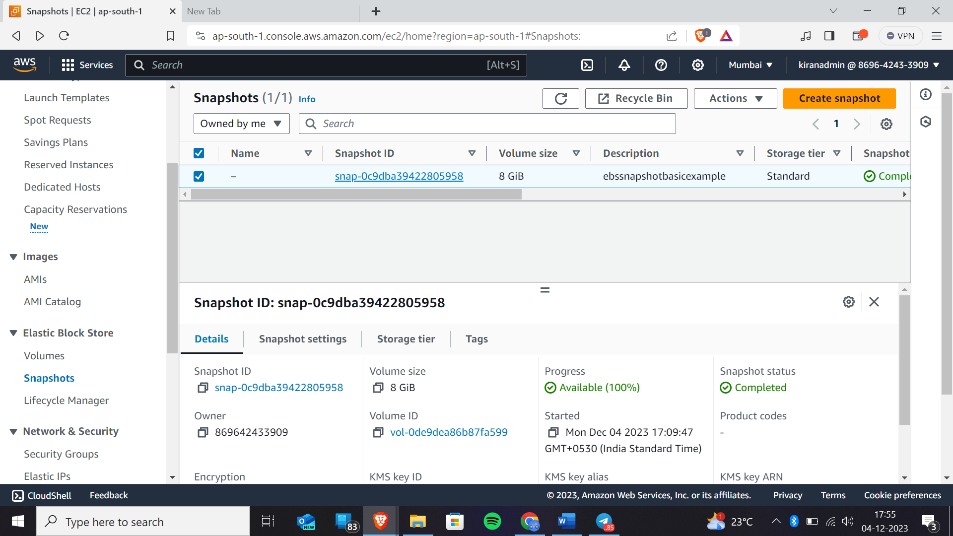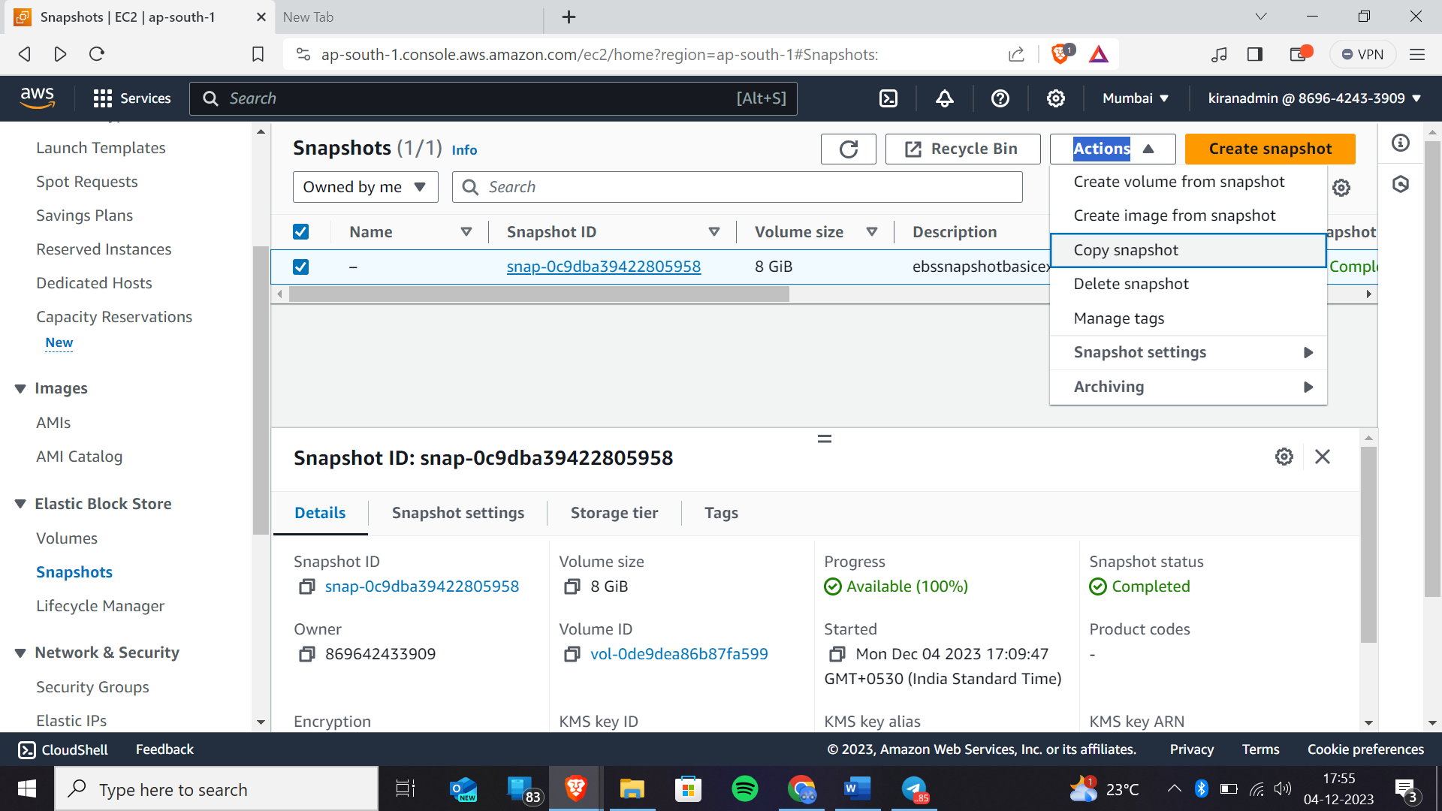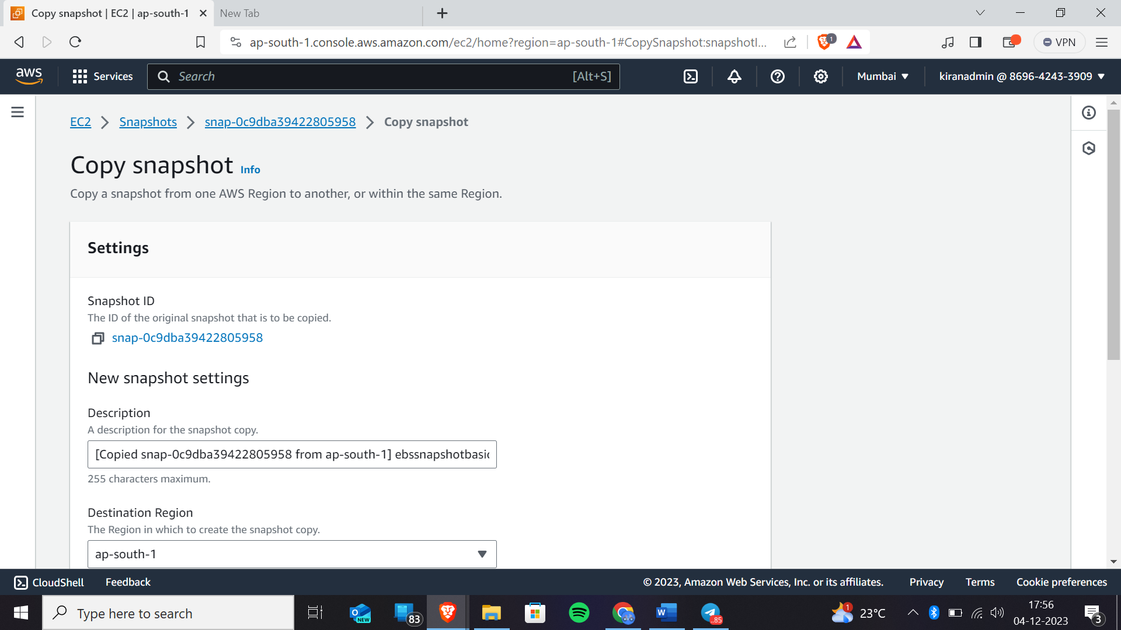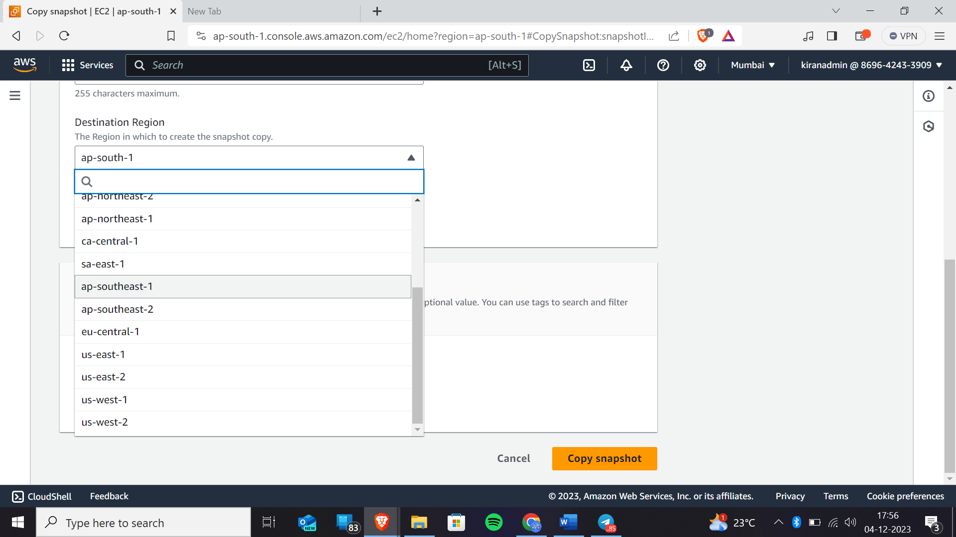Here you can select which for which availability zone you wanted to make a copy of that.

Now click on create copy snapshot

We have successfully copied to the another availability zone